Name:_______________________ 11R - One Flew Over the Cuckoo’s Nest
Part 4 -- Reading Schedule & HW
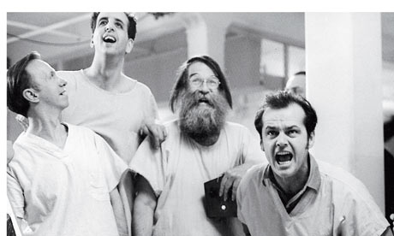
*Subject to Change
Week of 4/27: | Pages: | Focus for Notes:
HW: Tuesday, 4/29 | 219-231 | - Nurse’s Attempt to Turn Ward Against McMurphy  - Chief & The Control Panel  - The Shower Fight & Consequences
HW: Wednesday, 4/30 | 232-241 | - Kindly Nurse & Her View of Big Nurse  - Big Nurse’s Ultimatum  - Christ Imagery (pg. 237)  - Chief’s Reaction to Treatment
HW: Thursday, 5/1 (Due Monday) | 242-259 | - Chief Fights the Fog  - McMurphy’s Reactions to Treatments  - Chief Returns to the Ward  - Laughter  - McMurphy’s Return to the Ward  - Billy Bibbit & Date Night  - Sandy & Candy Visit  - The Plan to Cover Up Their Evening  - What now? Dealing with “Tomorrow”
HW: Monday, 5/5 | 260-272  (The End) | - Billy Bibbit  - Nurse vs. McMurphy  - The Exodus  - McMurphy on Display  - Chief’s Final Moves
For Each Reading Chunk, You Should Have:
- Heading:
- Plot Details/Highlights Significance (for each heading)
- 1-2 Key Quotes Explanations (for the overall chunk)
*Be prepared to share and discuss in groups

