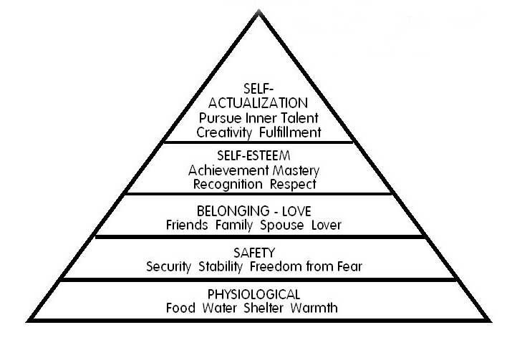
Name:______________________
English 11R

CHARACTER/PERSON
BEING ANALYZED:_____________________

**Note, not all columns will be filled in. It depends on the person’s journey.
Level | Evidence That This Level Has Been Fulfilled | Roadblocks to Fulfilling this Level (past or present conflicts)? | Person’s Reaction to This Conflict(s) - (Consider Coping Mechanisms) | What Does the Person Need to Do To Reach the Next Level?
Self-Actualization:
Pursue Inner Talent, Creativity, Fulfillment
Self-Esteem: Achievement, Mastery, Recognition, Respect

Belonging/Love: Friends, Family, Spouse, Lover

Safety – Security: Stability, Freedom from Fear

Physiological: Food, Water, Shelter, Warmth

