Maslow's Hierarchy of Needs
by Saul McLeod Adapted from: www.simplypsychology.org/maslow/html

Abraham Maslow (1954) presents a hierarchy of needs model which can be divided into basic (or deficiency) needs (e.g. physiological, safety, love, and esteem) and growth needs (cognitive, aesthetics and self-actualization).
One must satisfy lower level basic needs before progressing on to meet higher level growth needs. Once these needs have been reasonably satisfied, one may be able to reach the highest level called self-actualization.
Every person is capable and has the desire to move up the hierarchy toward a level of self-actualization. Unfortunately, progress is often disrupted by failure to meet lower level needs. Life experiences including divorce and loss of job may cause an individual to fluctuate between levels of the hierarchy.
Maslow noted only one in a hundred people become fully self-actualized because our society rewards motivation primarily based on esteem, love and other social needs.
The original hierarchy of needs five-stage model includes:
1. Biological and Physiological needs - air, food, drink, shelter, warmth, sex, sleep, etc.
2. Safety needs - protection from elements, security, order, law, limits, stability, etc.
3. Belongingness and Love needs - work group, family, affection, relationships, etc.
4. Esteem needs - self-esteem, achievement, mastery, independence, status, dominance, prestige, managerial responsibility, etc.
5. Self-Actualization needs - realizing personal potential, self-fulfillment, seeking personal growth and peak experiences.
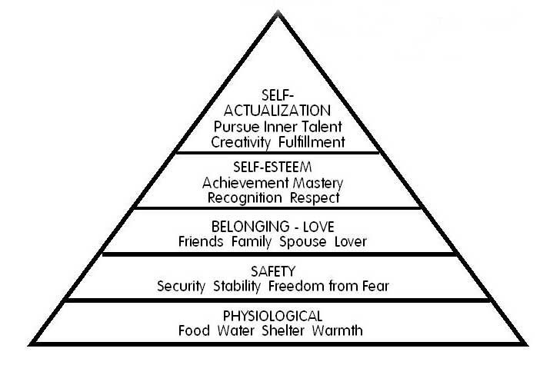

The expanded hierarchy of needs:
It is important to note that Maslow's (1954) theory has been elaborated upon by other researchers. Maslow's original five-stage model has been adapted by other researchers who have interpreted Maslow's writings to develop both seven and eight-stage hierarchy of needs pyramids.
Changes to the original five-stage model are highlighted and include a seven-stage model developed during the 1970s and a more recent eight-stage model developed during the 1990s.

Self-Actualization
Psychologist Abraham Maslow (1943, 1954) stated that human motivation is based on people seeking fulfillment and change through personal growth. Maslow described self-actualized people as those who were fulfilled and doing all they were capable of.
The growth of self-actualization (Maslow, 1962) refers to the need for personal growth that is present throughout a person’s life. For Maslow, a person is always “becoming” and never remains static in these terms. In self-actualization a person comes to find a meaning to life that is important to them.
Are you self-actualized?

Maslow (1968): Some of the characteristics of self-actualized people
Although we are all, theoretically, capable of self-actualizing, most of us will not do so, or only to a limited degree. Maslow was particularly interested in the characteristics of people whom he considered to have achieved their potential as persons. By studying people he considered to be self-actualized (including Abraham Lincoln and Albert Einstein) Maslow identified 15 characteristics of a self-actualized person.
Characteristics of self-actualizers:
1. They perceive reality efficiently and can tolerate uncertainty;
2. Accept themselves and others for what they are;
3. Spontaneous in thought and action;
4. Problem-centered (not self-centered);
5. Unusual sense of humor;
6. Able to look at life objectively;
7. Highly creative;
8. Resistant to enculturation, but not purposely unconventional;
9. Concerned for the welfare of humanity;
10. Capable of deep appreciation of basic life-experience;
11. Establish deep satisfying interpersonal relationships with a few people;
12. Peak experiences;
13. Need for privacy;
14. Democratic attitudes;
15. Strong moral/ethical standards.

Behavior leading to self-actualization:
(a) Experiencing life like a child, with full absorption and concentration;
(b) Trying new things instead of sticking to safe paths;
(c) Listening to your own feelings in evaluating experiences instead of the voice of tradition, authority or the majority;
(d) Avoiding pretense ('game playing') and being honest;
(e) Being prepared to be unpopular if your views do not coincide with those of the majority;
(f) Taking responsibility and working hard;
(g) Trying to identify your defenses and having the courage to give them up.
The characteristics of self-actualizers and the behaviors leading to self-actualization are shown in the list above. Although people achieve self-actualization in their own unique way, they tend to share certain characteristics. However, self-actualization is a matter of degree, 'There are no perfect human beings' (Maslow, 1970, p. 176).
It is not necessary to display all 15 characteristics to become self-actualized, and not only self-actualized people will display them. Maslow did not equate self-actualization with perfection. Self-actualization merely involves achieving ones potential. Thus someone can be silly, wasteful, vain and impolite, and still self-actualize. Less than two percent of the population achieves self-actualization.

Critical Evaluation…Some argue (among other things) the flaw in his theory:
Through examining cultures in which large numbers of people live in poverty (such as India) it is clear that people are still capable of higher order needs such as love and belongingness. However, this should not occur, as according to Maslow, people who have difficulty achieving very basic physiological needs (such as food, shelter etc.) are not capable of meeting higher growth needs. Also, many creative people, such as authors and artists (e.g. Rembrandt and Van Gough) lived in poverty throughout their lifetime, yet it could be argued that they achieved self-actualization.

